**Batch: C7 Roll No.: 57**

**Experiment / assignment / tutorial No. 1**

**Grade: AA / AB / BB / BC / CC / CD /DD**

**Signature of the Staff In-charge with date**

|  |
| --- |
| **TITLE:** Write a program to demonstrate use of basic data types in Python.  **AIM**: 1) Program to calculate salary of an employee  2) Program to perform string operations.  **OUTCOME:** Student will be able to  **CO1:** Formulate problem statement and develop the logic (algorithm/flowchart) for its solution.  **CO2:** Understand the concepts of data structures in python. |

Use of input output function, arithmetic operators in python and different operations on string.

**______________________________________________________________________**

**Resource Needed: Python IDE**

**______________________________________________________________________**

**Books/ Journals/ Websites referred:**

1. Reema Thareja, *Python Programming: Using Problem Solving Approach*, Oxford University Press, First Edition 2017, India
2. Sheetal Taneja and Naveen Kumar, *Python Programming: A modular Approach*, Pearson India, Second Edition 2018,India
3. https://www.geeksforgeeks.org/python-strings/?ref=lbp

**______________________________________________________________________**

**Theory:**

**How the input function works in Python:**

* When input() function executes program flow will be stopped until the user has given an input.
* The text or message displayed on the output screen to ask a user to enter input value is optional i.e. the prompt, will be printed on the screen is optional.
* Whatever you enter as input, the input function converts it into a string. If you enter an integer value still input() function convert it into a string. You need to explicitly convert it into an integer in your code using [typecasting](https://www.geeksforgeeks.org/taking-input-from-console-in-python/).

**Example:**

Name=input("Enter your name")

print('Hello, ' + Name)

Output:-

Enter your name Mahesh

Hello, Mahesh

**Python Arithmetic Operators:**

Assume variable **a** holds 10 and variable **b** holds 20, then

|  |  |  |
| --- | --- | --- |
| **Operator** | **Description** | **Example** |
| + Addition | Adds values on either side of the operator. | a + b = 30 |
| - Subtraction | Subtracts right hand operand from left hand operand. | a – b = -10 |
| * Multiplication | Multiplies values on either side of the operator | a * b = 200 |
| / Division | Divides left hand operand by right hand operand | b / a = 2 |
| % Modulus | Divides left hand operand by right hand operand and returns remainder | b % a = 0 |
| ** Exponent | Performs exponential (power) calculation on operators | a**b =10 to the power 20 |
| // | Floor Division - The division of operands where the result is the quotient in which the digits after the decimal point are removed. But if one of the operands is negative, the result is floored, i.e., rounded away from zero (towards negative infinity) − | 9//2 = 4 and 9.0//2.0 = 4.0, -11//3 = -4, -11.0//3 = -4.0 |

**Strings:**

We can create string simply by enclosing characters in quotes. Python treats single quotes the same as double quotes. Creating strings is as simple as assigning a value to a variable.

Example:-

var1= “Hello World”

var2=”Python Programming”

## String Special Operators:

Assume string variable **a** holds 'Hello' and variable **b** holds 'Python', then

|  |  |  |
| --- | --- | --- |
| **Operator** | **Description** | **Example** |
| + | Concatenation - Adds values on either side of the operator | a + b will give HelloPython |
| * | Repetition - Creates new strings, concatenating multiple copies of the same string | a*2 will give -HelloHello |
| [] | Slice - Gives the character from the given index | a[1] will give e |
| [ : ] | Range Slice - Gives the characters from the given range | a[1:4] will give ell |
| in | Membership - Returns true if a character exists in the given string | H in a will give 1 |
| not in | Membership - Returns true if a character does not exist in the given string | M not in a will give 1 |

## String Methods:

| **Function Name** | **Description** |
| --- | --- |
| [capitalize()](https://www.geeksforgeeks.org/string-capitalize-python/) | Converts the first character of the string to a capital (uppercase) letter |
| [casefold()](https://www.geeksforgeeks.org/casefold-string-python/) | Implements caseless string matching |
| [center()](https://www.geeksforgeeks.org/string-center-python/) | Pad the string with the specified character. |
| [count()](https://www.geeksforgeeks.org/python-string-count/) | Returns the number of occurrences of a substring in the string. |
| [encode()](https://www.geeksforgeeks.org/python-strings-encode-method/) | Encodes strings with the specified encoded scheme |
| [endswith()](https://www.geeksforgeeks.org/string-endswith-python/) | Returns “True” if a string ends with the given suffix |
| [expandtabs()](https://www.geeksforgeeks.org/python-expandtabs-method/) | Specifies the amount of space to be substituted with the “\t” symbol in the string |
| [find()](https://www.geeksforgeeks.org/python-string-find/) | Returns the lowest index of the substring if it is found |
| [format()](https://www.geeksforgeeks.org/python-format-function/) | Formats the string for printing it to console |
| [format_map()](https://www.geeksforgeeks.org/python-string-format_map/) | Formats specified values in a string using a dictionary |
| [index()](https://www.geeksforgeeks.org/python-string-index-applications/) | Returns the position of the first occurrence of a substring in a string |
| [isalnum()](https://www.geeksforgeeks.org/python-string-isalnum/) | Checks whether all the characters in a given string is alphanumeric or not |
| [isalpha()](https://www.geeksforgeeks.org/python-string-isalpha-application/) | Returns “True” if all characters in the string are alphabets |
| [isdecimal()](https://www.geeksforgeeks.org/python-string-isdecimal/) | Returns true if all characters in a string are decimal |
| [isdigit()](https://www.geeksforgeeks.org/python-string-isdigit-application/) | Returns “True” if all characters in the string are digits |
| [isidentifier()](https://www.geeksforgeeks.org/python-string-isidentifier/) | Check whether a string is a valid identifier or not |
| [islower()](https://www.geeksforgeeks.org/python-string-islower-method/) | Checks if all characters in the string are lowercase |
| [isnumeric()](https://www.geeksforgeeks.org/python-string-isnumeric-application/) | Returns “True” if all characters in the string are numeric characters |
| [isprintable()](https://www.geeksforgeeks.org/isprintable-python-application/) | Returns “True” if all characters in the string are printable or the string is empty |
| [isspace()](https://www.geeksforgeeks.org/python-string-isspace-application/) | Returns “True” if all characters in the string are whitespace characters |
| [istitle()](https://www.geeksforgeeks.org/python-string-istitle/) | Returns “True” if the string is a title cased string |
| [isupper()](https://www.geeksforgeeks.org/python-string-isupper-method/) | Checks if all characters in the string are uppercase |
| [join()](https://www.geeksforgeeks.org/join-function-python/) | Returns a concatenated String |
| [ljust](https://www.geeksforgeeks.org/string-rjust-ljust-python/)() | Left aligns the string according to the width specified |
| [lower()](https://www.geeksforgeeks.org/python-string-lower/) | Converts all uppercase characters in a string into lowercase |
| [lstrip()](https://www.geeksforgeeks.org/python-string-lstrip-method/) | Returns the string with leading characters removed |
| [maketrans](https://www.geeksforgeeks.org/python-maketrans-translate-functions/)() | Returns a translation table |
| [partition()](https://www.geeksforgeeks.org/string-partition-python/) | Splits the string at the first occurrence of the separator |
| [replace()](https://www.geeksforgeeks.org/python-string-replace/) | Replaces all occurrences of a substring with another substring |
| [rfind()](https://www.geeksforgeeks.org/python-string-rfind/) | Returns the highest index of the substring |
| [rindex()](https://www.geeksforgeeks.org/string-rindex-python/) | Returns the highest index of the substring inside the string |
| [rjust()](https://www.geeksforgeeks.org/string-rjust-ljust-python/) | Right aligns the string according to the width specified |
| [rpartition()](https://www.geeksforgeeks.org/python-string-rpartition/) | Split the given string into three parts |
| [rsplit()](https://www.geeksforgeeks.org/python-string-rsplit/) | Split the string from the right by the specified separator |
| [rstrip()](https://www.geeksforgeeks.org/python-string-rstrip/) | Removes trailing characters |
| [splitlines()](https://www.geeksforgeeks.org/python-string-splitlines/) | Split the lines at line boundaries |
| [startswith()](https://www.geeksforgeeks.org/python-string-startswith/) | Returns “True” if a string starts with the given prefix |
| [strip()](https://www.geeksforgeeks.org/python-string-strip/) | Returns the string with both leading and trailing characters |
| [swapcase()](https://www.geeksforgeeks.org/python-string-swapcase/) | Converts all uppercase characters to lowercase and vice versa |
| [title()](https://www.geeksforgeeks.org/title-in-python/) | Convert string to title case |
| [translate()](https://www.geeksforgeeks.org/python-string-translate/) | Modify string according to given translation mappings |
| [upper()](https://www.geeksforgeeks.org/python-string-upper/) | Converts all lowercase characters in a string into uppercase |
| [zfill()](https://www.geeksforgeeks.org/python-string-zfill/) | Returns a copy of the string with ‘0’ characters padded to the left side of the string |

**Problem Definition:**

1) Write a python program to calculate salary of an employee given his basic pay (to be entered by user), HRA = 10 percent of basic pay, TA = 5 percent of basic pay. Define HRA and TA as constants and use them to calculate the salary of the employee.

2) a) Create a variable and assign it the string “Python programming”

b) Access the character “i” from the variable by index and print it

c) Find the length of the string

d) Print the slice “Python” from the variable

e) Print the slice “program” from the variable

f) Get the string “thing” from the variable

g) Convert string into uppercase.

h) Create another variable and assign it the string “is interesting”. Now concatenate both the strings

i) Apply different string methods given in table.

**Implementation details:**

**1)**

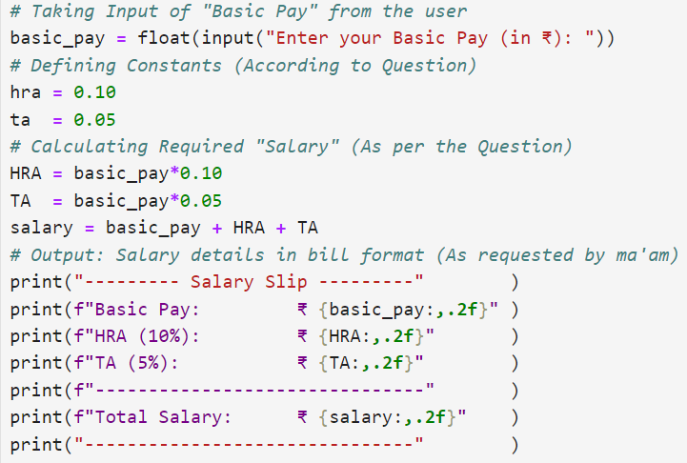

**2)**

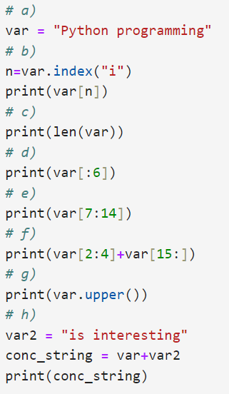

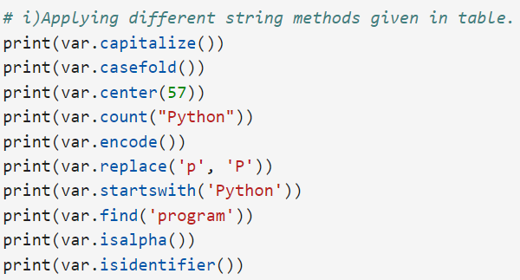

**Output(s):**

**1)**

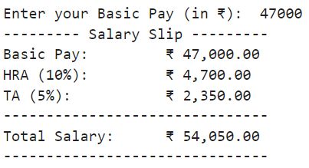

**2)**

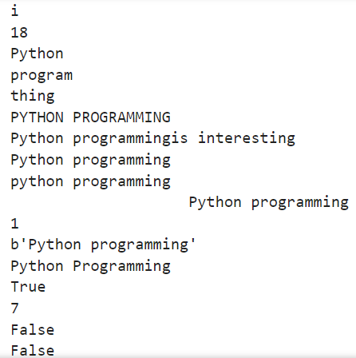

**Conclusion:**

In this lab experiment, I learned how to use basic arithmetic operations in Python, apply string formatting, and perform various Python string methods.

**Post Lab Descriptive Questions: -**

1. **Which data type will you use to represent the following data values?**
   1. **Number of days in a year**

**Ans.** Integer (int)

* 1. **The circumference of a circle**

**Ans.** Float (float)

* 1. **Distance between moon and earth**

**Ans.** Integer (int)

* 1. **Whether you will go for a trip?**

**Ans.** Boolean (bool)

* 1. **Name of your favourite celebrity**

**Ans.** String (str)